**PING Monitoring**

This article was updated to support v12.0 of Goliath Performance Monitor.

Server Watch rules monitor your servers/workstations using ICMP to execute ping checks for monitoring system availability. To create a PING monitoring rule, go to **Configure>Monitoring Rules** and click the **New** button at the top of the page and choose the option for **Serverwatch** in the last section.

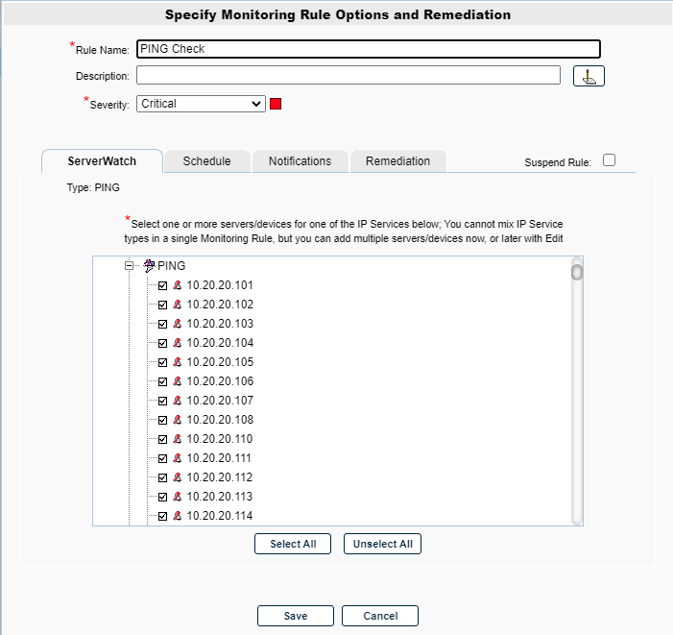

**Configure an ServerWatch rule**

**ServerWatch Tab**

1. Name the Monitoring Rule in the **Rule Name** field as well as define the description and the severity.
2. In the Selections Tree, under the **PING** dropdown select the machines that you want to monitor with this rule

**Schedule Tab**

In this tab you will define how often you would like the alerts to trigger.

**Required Options** (one of the below must be selected):

* Alert Every Time Checkbox
  + When this option is selected, you will receive the alert every time the specified condition is met.
* Minimal Notification Interval
  + When selected, it defines the minimal interval that must elapse between events for this alert before another alert will be generated. For example, if the interval is 15 minutes and the condition is being met, you will receive 1 alert every 15 minutes instead of being alerted at each occurrence. However, each alert occurrence is considered unique based on the details.  For example, an Event Log alert is considered the same based on being the same Event Type and ID, from the same server/workstation.

**Additional Options**:

* Maximum Alert Notifications
  + By default, "0" is chosen which means infinite. As long as the event is triggering based on the above required scheduling interval option configured notifications will be triggered and logged in the database.
  + This field can be changed to any other number and that will determine how many times the event is triggered. For example, if "5" is selected, the event will log/trigger for the first 5 events and all additional events will not.
* Service Check Frequency, Every
  + By Default, ping checks are executed every 5 mins
  + This setting can be changed however is its highly recommended to check more frequent then 5 mins
* Alert 1st time After ___ Failures
  + This field allows you to only trigger if the event is happening continuously.
  + For example, if 5 is defined, the event will not trigger until it has occurred 5 times or more. Events 1-4 will be ignored.

**Additional Configuration**

For additional configuration options please see the following articles:

* Enabling Notifications:
  + [Configure Email and Text Alert Notifications](https://support.goliathtechnologies.com/hc/en-us/articles/360024446933)
  + [Configure SNMP Alert Notifications](https://support.goliathtechnologies.com/hc/en-us/articles/360024726913)
  + [Configure Syslog Alert Notifications](https://support.goliathtechnologies.com/hc/en-us/articles/360024346594)
* [Configure Custom Remediation](https://support.goliathtechnologies.com/hc/en-us/articles/360024446633)